What is Scanner?
The Scanner class is used to take input from the user in Java.
It is part of the java.util package.
To use it, we must import it at the top of our program:
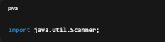
How to Create a Scanner Object :
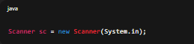
Here:
- Scanner → is the class name.
- sc → is the object name (you can use any name).
- System.in → means input will come from the keyboard.

Common Scanner Methods :
Method | Used To Take | Example
nextInt() | Integer input | Roll number, age, etc.
nextFloat() | Float input | Price, marks, etc.
nextDouble() | Double input | Salary, distance, etc.
next() | Single word String input | Name, city, etc.
nextLine() | Whole line String input (including spaces) | Full name, sentence, etc.

Example 1: Taking Integer Input
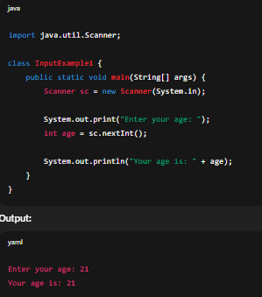
Example 2: Taking String Input (Single Word)
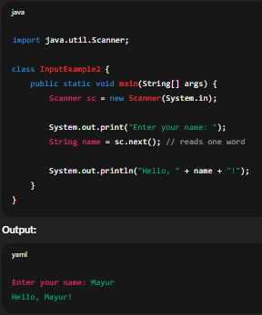

Example 3: Taking Full Line String Input
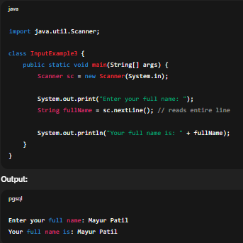
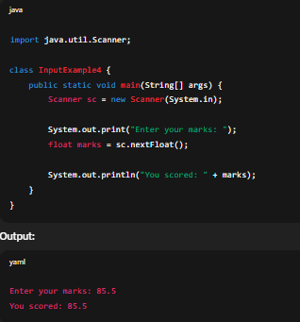
Example 4: Taking Float Input

Example 5: Taking Double Input
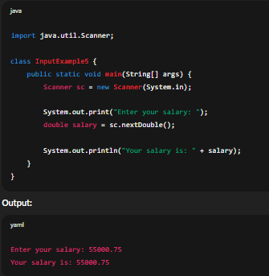
Important Notes
- Always import java.util.Scanner at the top.
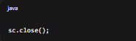
- Don’t forget to close the Scanner when you’re done using:
- nextLine() reads everything including spaces,
but next() stops reading after the first space.
- Avoid using nextLine() right after nextInt() or nextFloat() without handling the leftover newline.

Problem: Using nextLine() right after nextInt() or nextFloat()
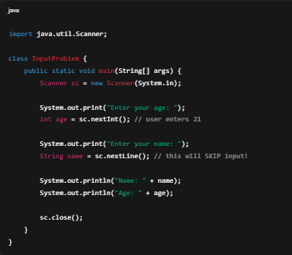
❌ Wrong Example (will cause issue)

What happens here
- When you type 21 and press Enter,
→ nextInt() reads only the number 21.
→ But it leaves the Enter key (\n) still in the input buffer.
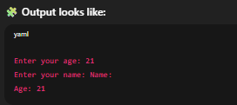
- Then, when nextLine() runs,
→ it reads that leftover \n (empty line).
→ So it skips asking for name, and name becomes an empty string.

Correct Example (handling the leftover newline)
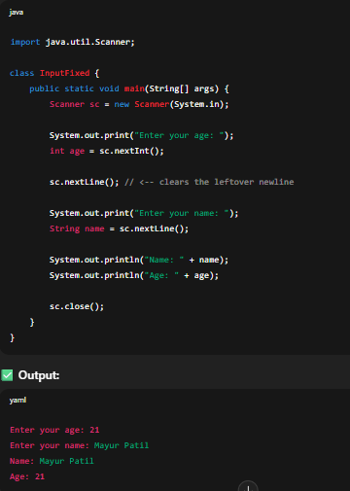
You just need to add one extra nextLine() after nextInt() to clear the buffer.

